COSTUME NOTES

GROUP 1

Abbey – Let’s Get Physical
Costume: 80’s Inspired Workout Theme- costumes provided by ADT
Hair: High Ponytails or Space Buns
Tights: Tan
Shoes: Tennis Shoes

Mark – Recess
Costume: Playground Play Clothes/Sport Clothes – provided by dancer
Hair: Various – Messy (kids are playing at recess)
Tights: None
Shoes: Tennis Shoes

GROUP 2/3

Andrea – Don’t Lose Site
Costume: 90s inspired hip hop (pastels-pink, green, purple, denim)
Mixture of any of the following:
- Denim jackets, Bomber Jackets
- Biker shorts with oversized tee, Mom jeans, Overalls
- Tracksuit vibes
- Scrunchies, Bucket hat, Backwards hat, Bandanas
- Oversized shirts over
- Plaid
- Mini skirt, Slip dress with t-shirt under
- Keds, Combat Boots
- Gold chains, Big Hoops, Chokers

Amber – Feelin’ Good
Costume: Girls- Black Beaded Tops & Pants Provided By ADT
Boys – Black Suit Jackets provided by ADT
White Crew Neck T-Shirt and Black Dress Pants Provided by Dancer
Hair: High Ponytails
Tights: Black
Shoes: Black Jazz Shoes

GROUP 4

Mark Opener – Back On Stage
Costume: Dancer provided costumes per attached board
Hair: Girls hair should be off their face.

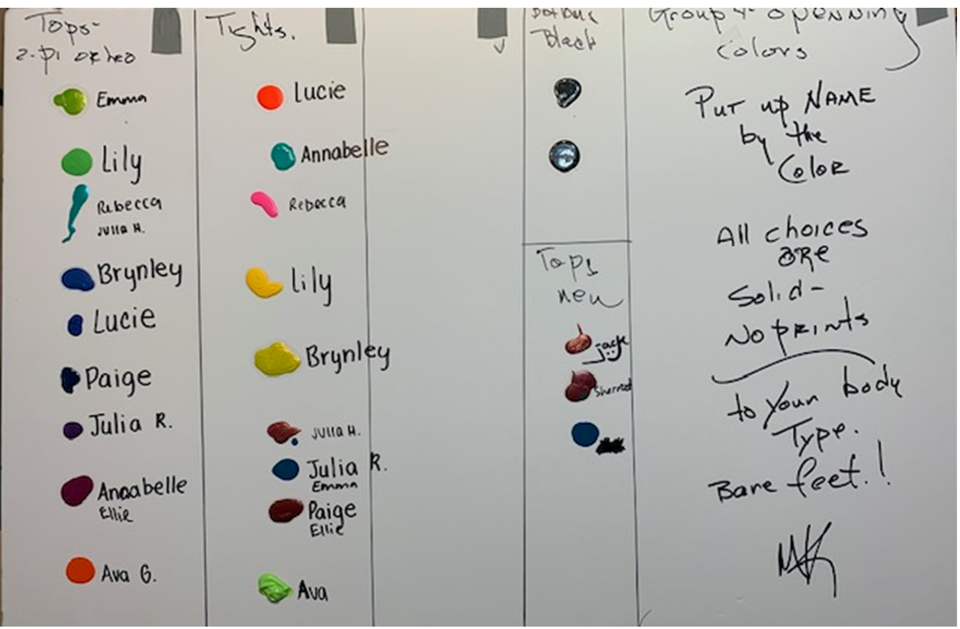

Mark – Satisfied
Costume: Black Fosse Outfit same as Act 3
Hair: Girls hair off their face
Tights/Socks: Black Tights/Black Socks
Shoe: Black Tap

Hannah – Jeux d’Enfants
Costume: Girls – Dresses provided by ADT
Boys – Black button-down shirts, black dress pants, black belt
Hair: Low bun with left part, sparkly hair piece from last year’s ballet costume
Tights: Pink with Back seam
Shoes: Girls – Pink Ballet
Boys – Black Ballet with black socks

Mark -A Little Something
Costume: Julia – Black skirt and leotard provided by ADT
Jack: Black button-down shirt untucked and black pants
Hair: Down
Tights: None
Shoes: Barefoot

Mark - Our Lives
Costume: Pink dance dresses provided by ADT
Hair: Same as Hannah’s dance
Tights: None
Shoes: Barefoot

Mark – Letters from War
Costume: Julia H. – Dress provided by ADT, hair down and messy, barefoot
Julia R – Shorts and shirt provided by ADT, hair in bun, barefoot
Jack/Noah - Army pants, t-shirt and hat, Jack captain jacket provided by ADT, black
Jazz shoes, black socks
Henry, Grant, Noah, Sherrod, Gavin – Dancer provided long sleeved black t-shirt,
black pants, black ski mask, black jazz shoes,
black socks

ACT 3

Costume: All dancers – all black form fitting Fosse inspired outfits provided by the dancer (will be used for all of Act 3
Hair: Girls hair away from their face
Tights/Socks: Black tights/Black Socks
Shoes: Black jazz or black character (whichever is appropriate for the dance per Ashley’s
Instruction)

Magic To Do
Costume Extras: white gloves – provided by ADT

Willommen
Jack – White crew neck t-shirt with suspenders under black button-down shirt. Suspenders and
black shirt provided by ADT

I Wanna Be A Dancin’ Man
Costume Extras: Boater Hats and white gloves provided by ADT

Shoeless Joe
Costume Extras – Baseball hats – ADT will provide unless dancer already has either a Cardinal’s Hat or Plan Red Hat Similar to below. Bats will be provided by ADT. Dancer should provide their own baseball glove. Please bring props to next rehearsal.

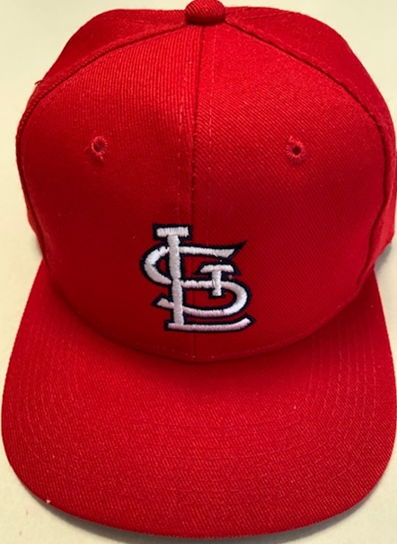

Rich Man’s Frug
Costume Extra’s – Long white satin gloves provided by ADT
Gavin, Henry, Joe, Grant – Black Jackets provided by ADT

Magic To Do
All props provided by ADT.

